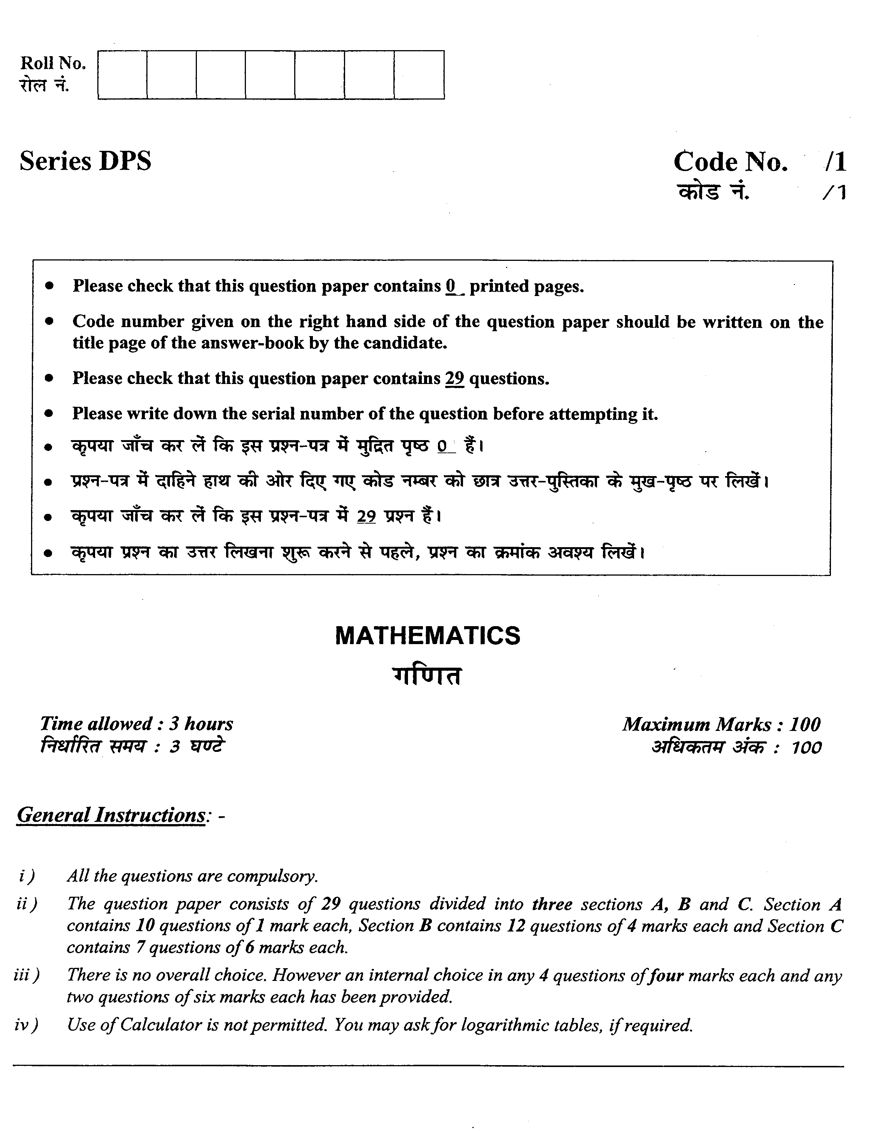

(1) P.T.O.

**Section – A**

***(****Questions number 1 to 10 carry 1 marks each)*

1. Find the principal value of .
2. Solve 
3. Find the order and degree of the differential equation..
4. Without actual expanding write the value of.
5. If 
6. Differentiate w.r.t. ‘x’,  .
7. Find the distance between the parallel planes .
8. 
9. Find a vector in the direction of given vector  having magnitude 8 units.
10. Find the sine of the angle between the vectors.

**Section-B**

**(***Questions number 11 to 22 carry 4 marks each.***)**

11. 

**OR**

Given  show that is the identity element for the operation * and all the elements A of P(X) are invertible with A-1=A.

1. By using the properties of determinants prove that :



(2) P.T.O.

1. Show that 

**OR**

Show that , 

14. If 

1. Verify the applicability of the Rolle’s Theorem for the function 
2. For what value of *a* and *b*, the function defined as:



17. Evaluate 

18. Evaluate 

19. Evaluate 

1. . 

OR

A girl walks 5 km towards west, and then she walks 3 km in a direction 60° east of north and stops. Determine the girl’s displacement from her initial point of departure. *Respect the girl implies respect the nation comment on it.*

1. Find the length of the perpendicular drawn from the point (2, -3,1) to the line

.

1. Consider the experiment of tossing a coin. If the coin shows head, toss it again but if it shows tail, then throw a die. Find the conditional probability of the event that ‘the die shows a number greater than 4’ given that ‘there is at least one tail’.

OR

Let *E* and *F* be two independent events. The probability that exactly one of them occurs is and the probability of none of them occurring is . If P(T) denotes the probability of the occurrence of the event T, then find the value of P(E) and P(F).

(3) P.T.O.

Section-C

*(Question number 23 to 29 carry 6 marks each)*

23. Using elementary transformations, find the inverse of



24. The total cost function and demand function of an item are given byWrite the total revenue function. Find the number of items when the profit will be maximum. Find the maximum profit also.

**OR**

Find the equation of tangents to the curve y= cos (*x* + *y*),  that are parallel to the line *x* + 2*y* = 0.

25. Find the area lying above x-axis and included between the circle  and inside the parabola.

1. Solve the differential equationand.

**OR**

Solve the differential equation 

1. Assume that the chance of a patient having a heart attack is 40%. It is also assumed that a meditation and yoga course reduce the risk of heart attack by 30% and prescription of certain drug reduces its chances by 25%. At a time a patient can choose any one of the two options with equal probabilities. It is given that after going through one of the two options the patient selected at random suffers a heart attack. Find the probability that the patient followed a course of meditation and yoga? *Why Meditation and Yoga is necessary and sufficient thing for peace in mind and for good health.*
2. Find the vector equation of the line passing through (1, 2, 3) and parallel to the plane
3. An aero plane can carry a maximum of 200 passengers. A profit of rupee symbol Rupee Symbol1000 is made on each executive class ticket and a profit of rupee symbol Rupee Symbol600 is made on each economy class ticket. The airline reserves at least 20 seats for executive class. However, at least 4 times as many passengers prefer to travel by economy class than by the executive class. Determine how many tickets of each type must be sold in order to maximize the profit for the airline. What is the maximum profit? *How one should respect the hard earn money of parents/guardians in a best economical way.*

_________________

(4)

Pre-board Examination 2012-13

Marking Scheme

|  |  |  |
| --- | --- | --- |
| S. No. | View Points | Marks |
|  |  | **1** |
|  | 0 | **1** |
|  | Order: 2, Degree:1 | **1** |
|  | 0 | **1** |
|  |  | **1** |
|  | - sin x | **1** |
|  |  | **1** |
|  | **0**(zero) | **1** |
|  |  | **1** |
|  |  | **1** |
|  | fog(x)=f(g(x))=f(-1)=-1  again gof(x)=g(f(x))=g(-1)=[-1]=-1  thus for all x in[-1,0) fog(x)=gof(x)  **OR**  It is given that *: P(*X*) × P(*X*) → P(*X*) is defined as  *A* * *B* = (*A* − *B*) ∪ (*B* − *A*) for every *A*, *B* ∈ P(*X*).  Let *A*∈ P(*X*). Then, we have:  *A* * *Φ* = (*A* − *Φ*) ∪ (*Φ* − *A*) = *A* ∪ *Φ* = *A*  Φ * *A* = (*Φ* − *A*) ∪ (*A* − *Φ*) = *Φ* ∪ *A* = *A*  ∴*A* * *Φ* = *A* = *Φ* * *A*. *A* ∈ P(*X*)  Thus, *Φ* is the identity element for the given operation*.  Now, an element *A* ∈ P(*X*) will be invertible if there exists *B* ∈ P(*X*) such that  *A* * *B* = *Φ* = *B* * *A*. (As Φ is the identity element)  Now, we observed thathttp://cbse.meritnation.com/img/curr/1/12/15/230/6144/Chapter%201_html_m3df80437.gif.  Hence, all the elements *A* of P(*X*) are invertible with *A*−1 = *A*. | 1+1/2  1+1/2  1  **1**  **1**  **1**  **1** |
|  | Multiply *abc* in rows and take *abc* common from column  Now R1=R1+R2+R3  Then R3= R3 - R1 and R2 = R2 - R1  then expand to get the result. | 1  1  1  1 |
|  |  | **½**  **1**  **1**  **½**  **1** |
|  |  |  |
|  | http://cbse.meritnation.com/img/curr/1/12/15/234/7065/Chapter%205_html_m44367968.gif  Then, equation (1) reduces to  http://cbse.meritnation.com/img/curr/1/12/15/234/7065/Chapter%205_html_5fe02a49.gif | **1**  **1**  **1**  **1** |
|  | Continuous on  Differentiable at | **1**  **1**  **1**  **1** |
|  | L.H.L.=5a-2b  and  R.H.L.=3a+b  a= 3  b=2 | **1**  **1**  **1**  **1** |
|  | http://cbse.meritnation.com/img/curr/1/12/15/236/7922/NCERT_Solution_Math_Chapter_7_final_html_474a8251.gif | **1**  **1**  **1**  **1** |
|  | http://cbse.meritnation.com/img/curr/1/12/15/236/7625/NCERT_Solution_Math_Chapter_7_final_html_445b6746.gif  Equating the coefficients of *x* and constant term, we obtain  http://cbse.meritnation.com/img/curr/1/12/15/236/7625/NCERT_Solution_Math_Chapter_7_final_html_m58eeddc7.gif  http://cbse.meritnation.com/img/curr/1/12/15/236/7625/NCERT_Solution_Math_Chapter_7_final_html_m224dadf8.gif  Any justified reason which will give deep sense of national integration will be awarded by one mark. | **1**  **1**  **1/2**  **1/2**  1 |
| **19.** |  | **1**  **1**  **1**  **1** |
|  | Lethttp://cbse.meritnation.com/img/curr/1/12/15/239/7620/NCERT_10-11-08_Khushboo_12_Math_Ex-10.1_5.doc_SG_html_m75613acd.gif.  Sincehttp://cbse.meritnation.com/img/curr/1/12/15/239/7620/NCERT_10-11-08_Khushboo_12_Math_Ex-10.1_5.doc_SG_html_m42cf08f4.gifis perpendicular to bothhttp://cbse.meritnation.com/img/curr/1/12/15/239/7620/NCERT_10-11-08_Khushboo_12_Math_Ex-10.1_5.doc_SG_html_4f2bfef5.gifandhttp://cbse.meritnation.com/img/curr/1/12/15/239/7620/NCERT_10-11-08_Khushboo_12_Math_Ex-10.1_5.doc_SG_html_6d43734a.gif, we have:  http://cbse.meritnation.com/img/curr/1/12/15/239/7620/NCERT_10-11-08_Khushboo_12_Math_Ex-10.1_5.doc_SG_html_52f0ac0b.gif  Also, it is given that:  http://cbse.meritnation.com/img/curr/1/12/15/239/7620/NCERT_10-11-08_Khushboo_12_Math_Ex-10.1_5.doc_SG_html_m5fa5d036.gif  On solving (i), (ii), and (iii), we get:  http://cbse.meritnation.com/img/curr/1/12/15/239/7620/NCERT_10-11-08_Khushboo_12_Math_Ex-10.1_5.doc_SG_html_f46c9fa.gif  Hence, the required vector ishttp://cbse.meritnation.com/img/curr/1/12/15/239/7620/NCERT_10-11-08_Khushboo_12_Math_Ex-10.1_5.doc_SG_html_1d51b915.gif.  *Directionless student/youth is just like a stone on road any one can misguide him or her and drive them as per their own will, as they don’t have any ambition or any aim moreover they always frustrated from the world and such type of people are the burden on society and the country.*  OR  Let O and B be the initial and final positions of the girl respectively.  Then, the girl’s position can be shown as:  http://cbse.meritnation.com/img/curr/1/12/15/239/7597/NCERT_10-11-08_Khushboo_12_Math_Ex-10.1_5.doc_SG_html_32346bc6.jpg  Now, we have:  http://cbse.meritnation.com/img/curr/1/12/15/239/7597/NCERT_10-11-08_Khushboo_12_Math_Ex-10.1_5.doc_SG_html_7d133f98.gif  By the triangle law of vector addition, we have:  http://cbse.meritnation.com/img/curr/1/12/15/239/7597/NCERT_10-11-08_Khushboo_12_Math_Ex-10.1_5.doc_SG_html_32d7b395.gif  Hence, the girl’s displacement from her initial point of departure is  http://cbse.meritnation.com/img/curr/1/12/15/239/7597/NCERT_10-11-08_Khushboo_12_Math_Ex-10.1_5.doc_SG_html_m78dd8623.gif.  *Respect the girls is the respect of the nation because if we respect the girls and ladies so we will respect the mother or sister or wife of someone’s and this respect will lead the nation from hate speeches and battle we should never forget Mahabharata Battle and Demolishing of Ravan is just because Ladies Dropadi and Seeta respectively* | **½**  **1**  **1**  **1**  **1**  **½(fig.)**  **1**  **1/2**  **1** |
|  | P  General point on the line  (2r-1,3r+3,-r-2) A Q B  Since PQ is perpendicular to AB  This will give r = -15/14  Q = (-22/7, -3/14, -13/14)  Now  PQ=. | **1/2**  **(Fig)**  **½**  **1**  **1**  **1** |
|  | S= {HH,HT, T1,T2,…T6}  E= {HT, T1,…T6} and F = {T5,T6}    P(F)=3/4  P(E intersection F)=1/6  P(E|F)=2/9  **OR**  Let P (E) = e and P (F) = f  P (E  F)  P (E  F) =11/25    e + f  2ef =11/25… (1)  PE F =2/25  (1  e) (1  f) =2/25  1  e  f + ef =2/25… (2)  From (1) and (2)  ef =12/25  and e + f =7/5  Solving, we get  e =4/ 3, f=3/5 or e=3/ 5, f = 4/5 | **1**  **1**  **1**  **1**  **1**  **1**  **1**  **1** |
|  | http://cbse.meritnation.com/img/curr/1/12/15/232/6369/Chapter%203_html_51907961.gif  We know that *A* = *IA*  http://cbse.meritnation.com/img/curr/1/12/15/232/6369/Chapter%203_html_3fd13b9.gif  Applying R2 → R2 + 3R1 and R3 → R3 − 2R1, we have:  http://cbse.meritnation.com/img/curr/1/12/15/232/6369/Chapter%203_html_m7602c1e3.gif  http://cbse.meritnation.com/img/curr/1/12/15/232/6369/Chapter%203_html_m386a771e.gif  http://cbse.meritnation.com/img/curr/1/12/15/232/6369/Chapter%203_html_m7d47c5d.gif | **1**  **1**  **1**  **1**  **½**  **½**  **1** |
|  | Revenue R = p x  Profit= R - C     * 111.33   **OR** | **1**  **1**  **1**  **1**  **1**  **1**  **1**  **1**  **1**  **1**  **1**  **1** |
|  | Correct fig(with proper stips and shading)  Points of intersection (4,0)and (4,4)  Required Area = area of region covered by parabola + area of the region covered by circle  = | **½+1**  **1**  **½**  **1**  **1**  **1** |
|  | **Now if .**  **Then c =**    **OR** | **1**  **1**  **1**  **1**  **1**  **1**  1  1  1  1  1  1 |
|  | Let A, E1, and E2 respectively denote the events that a person has a heart attack, the selected person followed the course of yoga and meditation, and the person adopted the drug prescription.  http://cbse.meritnation.com/img/curr/1/12/15/242/7899/NCERT_17-11-08_Gopal_12_Maths_Ex-13.1_17_MNK_SS_html_m1eaa89da.gif  http://cbse.meritnation.com/img/curr/1/12/15/242/7899/NCERT_17-11-08_Gopal_12_Maths_Ex-13.1_17_MNK_SS_html_19e8564f.gif  Probability that the patient suffering a heart attack followed a course of meditation and yoga is given by P (E1|A).  http://cbse.meritnation.com/img/curr/1/12/15/242/7899/NCERT_17-11-08_Gopal_12_Maths_Ex-13.1_17_MNK_SS_html_325a719.gif  *Yoga increase oxygen combustion in mind and body and meditation increase the concentration of mind. Then we get peace in mind and healthy body. As we know a healthy body can possesses healthy mind.* | **1**  **1/2**  **1**  **1**  **1**  **1+1/2** |
|  | Let the required line be parallel to vector http://cbse.meritnation.com/img/curr/1/12/1/240/7239/NS_14-11-08_Gopal_12_Math_Exercise%2011.1_5_MNK_SS_html_6d43734a.gifgiven by,  http://cbse.meritnation.com/img/curr/1/12/1/240/7239/NS_14-11-08_Gopal_12_Math_Exercise%2011.1_5_MNK_SS_html_m182a051d.gif  The position vector of the point (1, 2, 3) is http://cbse.meritnation.com/img/curr/1/12/1/240/7239/NS_14-11-08_Gopal_12_Math_Exercise%2011.1_5_MNK_SS_html_m1662cbf4.gif  The equation of line passing through (1, 2, 3) and parallel to http://cbse.meritnation.com/img/curr/1/12/1/240/7239/NS_14-11-08_Gopal_12_Math_Exercise%2011.1_5_MNK_SS_html_6d43734a.gifis given by,  http://cbse.meritnation.com/img/curr/1/12/1/240/7239/NS_14-11-08_Gopal_12_Math_Exercise%2011.1_5_MNK_SS_html_3e9a99d0.gif  The equations of the given planes are  http://cbse.meritnation.com/img/curr/1/12/1/240/7239/NS_14-11-08_Gopal_12_Math_Exercise%2011.1_5_MNK_SS_html_m7b56d0fb.gif  The line in equation (1) and plane in equation (2) are parallel. Therefore, the normal to the plane of equation (2) and the given line are perpendicular.  http://cbse.meritnation.com/img/curr/1/12/1/240/7239/NS_14-11-08_Gopal_12_Math_Exercise%2011.1_5_MNK_SS_html_m1f5b406b.gif  http://cbse.meritnation.com/img/curr/1/12/1/240/7239/NS_14-11-08_Gopal_12_Math_Exercise%2011.1_5_MNK_SS_html_56a2581.gif  From equations (4) and (5), we obtain  http://cbse.meritnation.com/img/curr/1/12/1/240/7239/NS_14-11-08_Gopal_12_Math_Exercise%2011.1_5_MNK_SS_html_809c22d.gif  Therefore, the direction ratios of http://cbse.meritnation.com/img/curr/1/12/1/240/7239/NS_14-11-08_Gopal_12_Math_Exercise%2011.1_5_MNK_SS_html_6d43734a.gifare −3, 5, and 4.  http://cbse.meritnation.com/img/curr/1/12/1/240/7239/NS_14-11-08_Gopal_12_Math_Exercise%2011.1_5_MNK_SS_html_m10bc00b6.gif  Substituting the value of http://cbse.meritnation.com/img/curr/1/12/1/240/7239/NS_14-11-08_Gopal_12_Math_Exercise%2011.1_5_MNK_SS_html_6d43734a.gif in equation (1), we obtain  http://cbse.meritnation.com/img/curr/1/12/1/240/7239/NS_14-11-08_Gopal_12_Math_Exercise%2011.1_5_MNK_SS_html_481bfd24.gif  This is the equation of the required line. | **1**  **1**  **1**  **1**  **1**  **1** |
|  | Let the airline sell *x*tickets of executive class and *y* tickets of economy class.  The mathematical formulation of the given problem is as follows.  Maximize *z* = 1000*x*+ 600*y* … (1)  subject to the constraints,  http://cbse.meritnation.com/img/curr/1/12/15/241/7145/NCERT_13-11-08_Khushboo_12_Maths_Ex-12.1_10_MNK_SS_html_m41b13265.gif  The feasible region determined by the constraints is as follows.  http://cbse.meritnation.com/img/curr/1/12/15/241/7145/NCERT_13-11-08_Khushboo_12_Maths_Ex-12.1_10_MNK_SS_html_347fa37d.jpg  The corner points of the feasible region are A (20, 80), B (40, 160), and  C (20, 180).  The values of *z* at these corner points are as follows.   |  |  |  | | --- | --- | --- | | **Corner point** | **z = 1000*x* + 600*y*** |  | | A (20, 80) | 68000 |  | | B (40, 160) | 136000 | → Maximum | | C (20, 180) | 128000 |  |   The maximum value of *z* is 136000 at (40, 160).  Thus, 40 tickets of executive class and 160 tickets of economy class should be sold to maximize the profit and the maximum profit is Rs 136000.  Any justified answer which give clear idea of saving of hard earn money by parents will be awarded | **½**  **1**  **2**  **Fig.**  **1**  **1+1/2** |